**HOW TO INSTALL VISUAL STUDIO CODE**

Step 1

Download the visual studio code on google search.

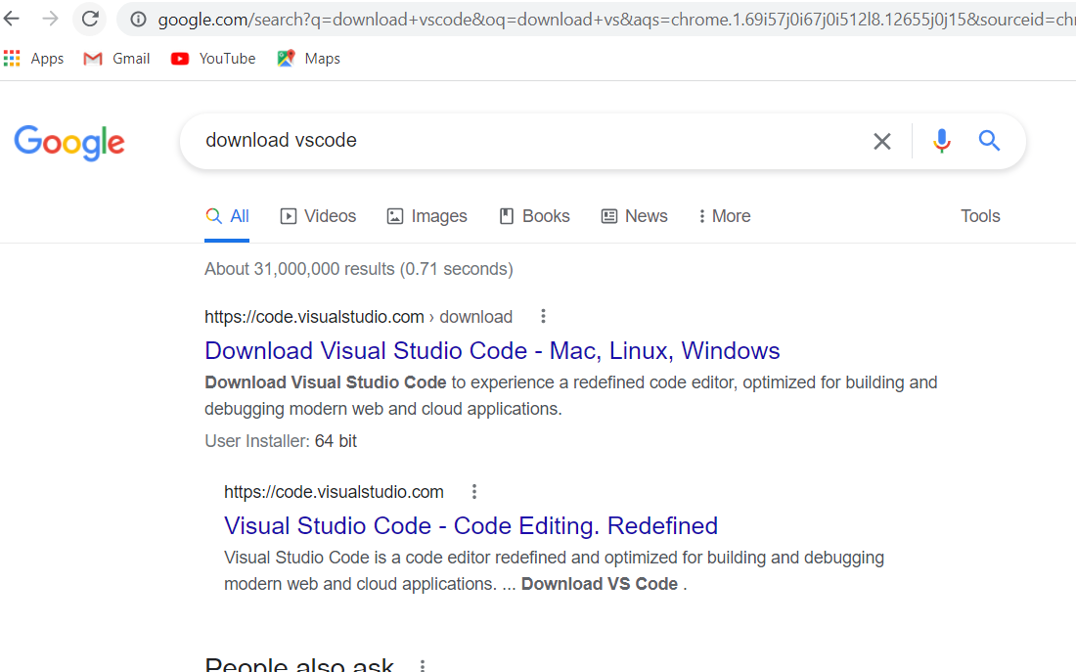

**Step 2**

Once it is downloaded the visual studio code, run the installer (VSCodeUserSetup-{version}.exe). Then, run the file, it will only take a minute. 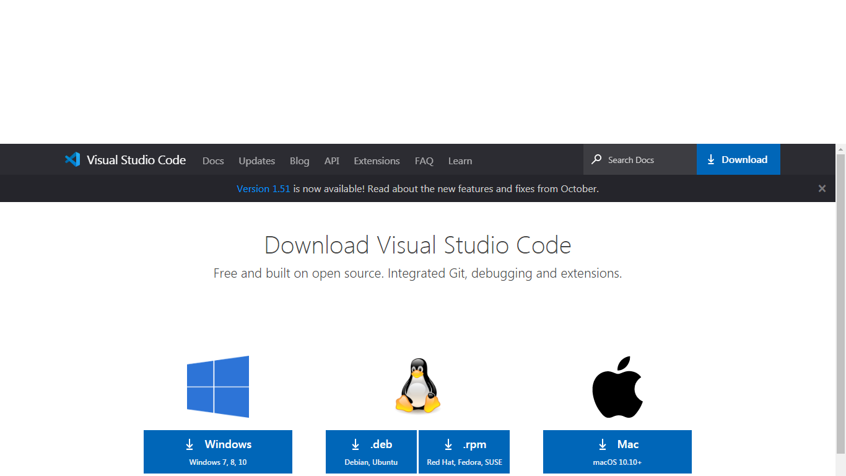

Step 3

Accept the agreement and click “next.”

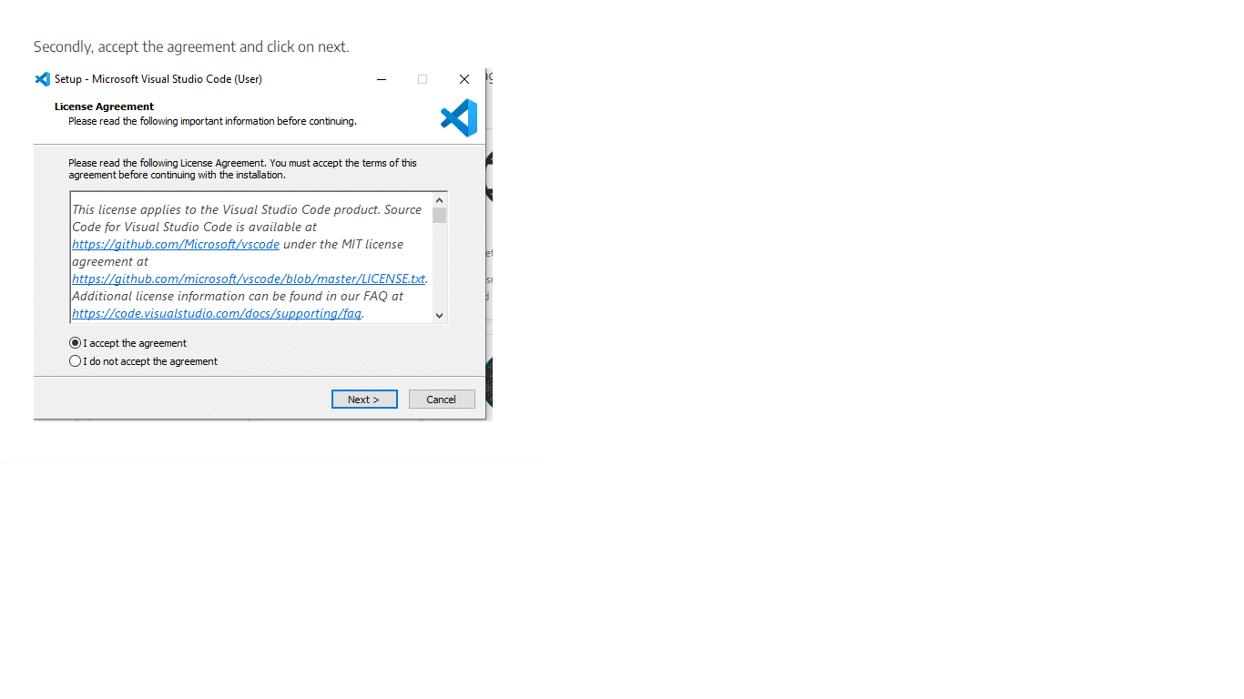

Step 4

After accepting all the requests press finish button.

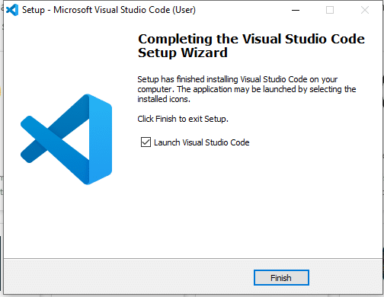

Step 5

If the installation is successful, you will see the following:

